19.10.2020

Remzi Tepe - 21802713

CS223-05 Lab 03

Digital Design and Computer Architecture

1919

**Behavioral SystemVerilog Module for 2-to-4 decoder:**

module twoTofourdecoder_behavioral(input logic in1, in0,

output logic y3, y2, y1, y0);

assign y3 = in1 & in0;

assign y2 = in1 & ~in0;

assign y1 = ~in1 & in0;

assign y0 = ~in1 & ~in0;

endmodule

**Testbench for 2-to-4 decoder:**

module testbench_decoderBehavioral();

logic in1, in0;

logic y3, y2, y1, y0;

twoTofourdecoder_behavioral dut(in1, in0, y3, y2, y1, y0);

initial begin

in1 = 0; in0 = 0; #100;

in0 = 1; #100;

in1 = 1; in0 = 0; #100

in1 = 1; in0 = 1; #100;

end

endmodule

Behavioral SystemVerilog Module for 4:1 Muliplexer:

module muxFourtoOne(input logic d0, d1, d2, d3,

input logic s0, s1,

output logic y);

assign y = s1 ? (s0 ? d3 : d2) : (s0 ? d1 : d0);

endmodule

**Block Diagram of 8-to-1 Multiplexer by using two 4-to-1 MUX, two AND gates, an inverter, and an OR gate.**

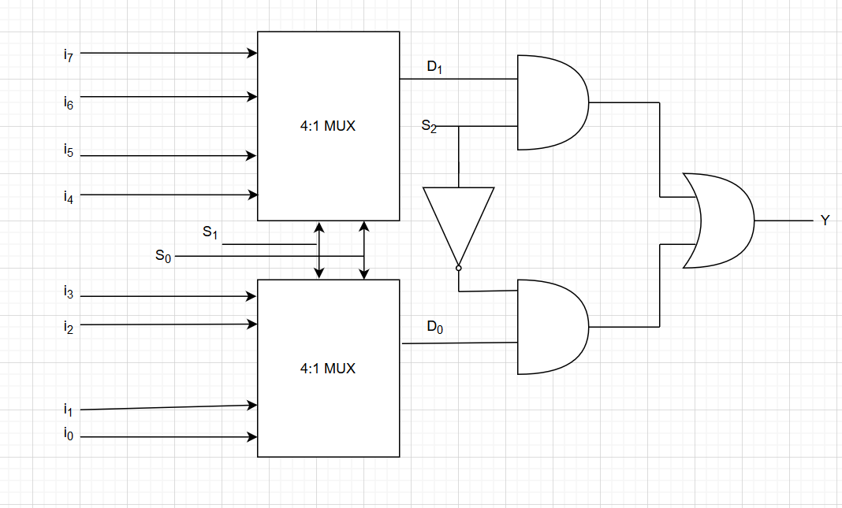

**SystemVerilog Module of it:**

module inv(input logic a,

output logic b);

assign b = ~a;

endmodule

module and2(input logic a, b,

output logic c);

assign c = a & b;

endmodule

module or2(input logic a, b,

output logic c);

assign c = a | b;

endmodule

module muxEighttoOne(input logic i0, i1, i2, i3, i4, i5, i6, i7,

input logic s2, s1, s0,

output logic y);

logic n1, n2, n3, n4, n5;

muxFourtoOne multiplexer4to1_1(i0, i1, i2, i3, s0, s1, n1);

muxFourtoOne multiplexer4to1_2(i4, i5, i6, i7, s0, s1, n2);

and2 andgate_1(n2, s2, n3);

inv inverter(s2, n4);

and2 andgate_2(n4, n1, n5);

or2 orgate(n3, n5, y);

endmodule

**Testbench for this structure:**

module testBenchforMuxEighttoOne();

logic i0, i1, i2, i3, i4, i5, i6, i7;

logic s2, s1, s0;

logic y;

muxEighttoOne name(.i0(i0), .i1(i1), .i2(i2), .i3(i3), .i4(i4), .i5(i5), .i6(i6), .i7(i7), .s2(s2), .s1(s1), .s0(s0), .y(y));

initial begin

i0 = 0; i1 = 0; i2 = 0; i3 = 0; i4 = 0; i5 = 0; i6 = 0; i7 = 0; s0 = 0; s1 = 0; s2 = 0;

#2000 $finish;

end

always #1 i7 = ~i7;

always #2 i6 = ~i6;

always #4 i5 = ~i5;

always #8 i4 = ~i4;

always #16 i3 = ~i3;

always #32 i2 = ~i2;

always #64 i1 = ~i1;

always #128 i0 = ~i0;

always #256 s0 = ~s0;

always #512 s1 = ~s1;

always #1024 s2 = ~s2;

endmodule

**Block Diagram of the function given in the Part E:**

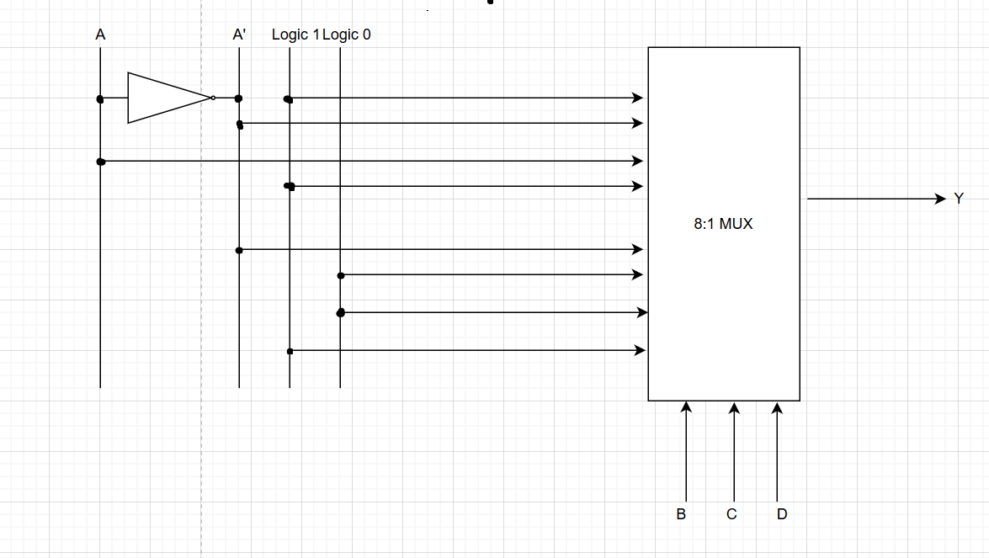

**SystemVerilog Module for this function:**

module muxFunction(input logic a, b, c, d,

output logic y);

logic n1;

inv inverter_mux(a, n1);

muxEighttoOne multiplexer8to1(1, n1, a, 1, n1, 0, 0, 1, b, c, d, y);

endmodule